College of Computer Sciences and Information Technology
King Faisal University
CE 322- Embedded System
Course Project

Project title: ESP32 Based Plant Vitals Monitor

Members:
Murtada Ramdan Alsmaiel

Submitted to:
Dr. Ramasamy

Date:
May 2025

I. Project Description/ Abstract

This project presents an ESP32-based plant vitals monitoring system designed to measure and log critical environmental parameters including soil moisture, light intensity, temperature, humidity, and various gas concentrations (CO, CH4, C2H5OH, H2, NH3, NO2). The system wirelessly transmits sensor data via Bluetooth to a mobile device for real-time monitoring. Additionally, the ESP32 communicates with an Arduino Uno to control a water pump that irrigates the plant based on soil moisture levels. This automated approach helps maintain optimal plant health by ensuring adequate watering and environmental awareness. And it could also be used to optimize carbon absorption by the plant. The project demonstrates successful integration of multiple sensors with microcontrollers and wireless communication, achieving reliable monitoring and automated irrigation.

II. Introduction
Maintaining healthy plants requires continuous monitoring of environmental conditions. Manual monitoring is time-consuming and prone to human error. Automating this process enhances plant care, conserves water and provides valuable data for better decision-making. Plants require precise environmental conditions to thrive, but gardeners often lack timely information on soil moisture, air humidity, temperature, and harmful gases. Without this data, plants may be overwatered or stressed by pollutants, affecting growth and carbon absorption. The system uses an ESP32 microcontroller to collect data from multiple sensors and send it to a smartphone via Bluetooth. It also triggers an Arduino-controlled water pump to automatically irrigate plants based on soil moisture readings, providing a smart plant care solution.
III. Objectives
- Design and implement a multi-sensor plant monitoring system.
- Measure soil moisture, light intensity, temperature, humidity, and gas concentration.
- Transmit sensor data wirelessly to a smartphone via Bluetooth.
- Automate irrigation by controlling a water pump based on soil moisture.
- Achieve reliable data storage on smartphone.
- Provide a user-friendly monitoring interface on the phone.

IV. System Architecture
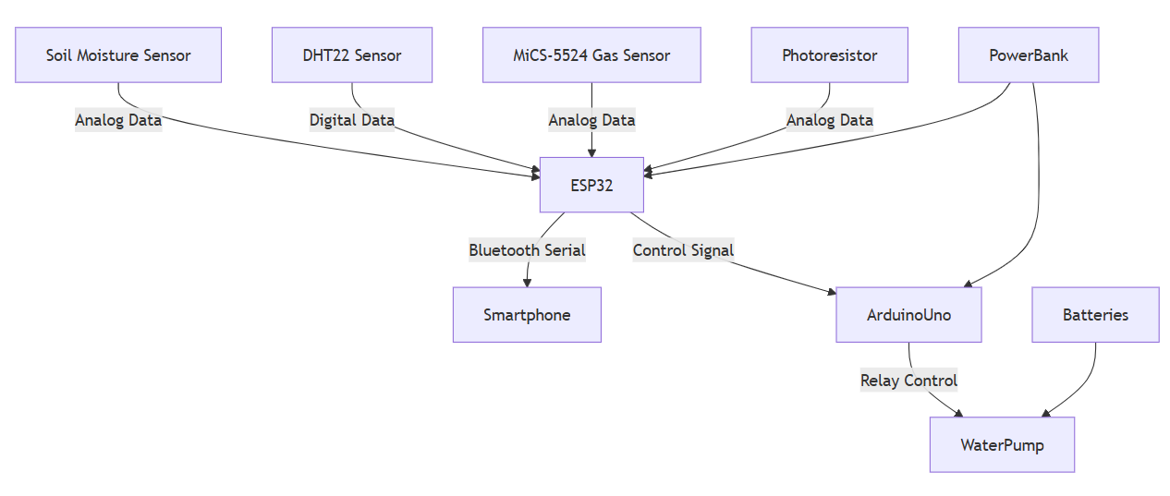
Components Description
- Resistive Soil Moisture Sensor: Measures soil moisture level to determine irrigation needs.
- DHT22 Sensor: Measures temperature and humidity near the plant.
- MiCS-5524 Gas Sensor: Detects multiple gases (CO, CH4, C2H5OH, H2, NH3, NO2) affecting plant health.
- Photoresistor: Measures ambient light intensity.
- ESP32 Dev Kit V1: Main microcontroller collecting sensor data and sending it via Bluetooth.
- Arduino Uno: Receives soil moisture signal from ESP32 and controls the water pump through a 5V relay.
- Water Pump + Relay: Pumps water to irrigate the plant when soil moisture is low.
- Power Supply: Four 1.5V batteries for the pump and a 5V 10000 mAh power bank for microcontrollers.

V. Design and Implementation
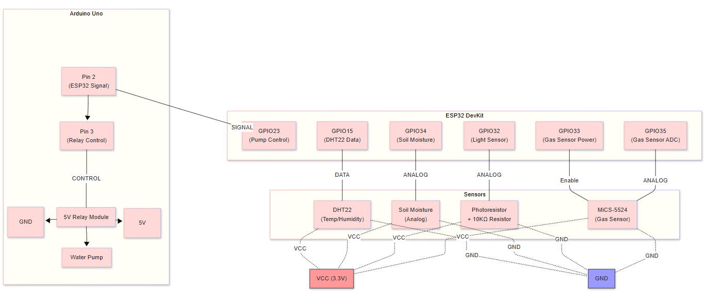
Hardware Design

- Soil moisture sensor connected to ESP32 analog input (GPIO34).
- DHT22 sensor connected to GPIO15 for temperature and humidity.
- MiCS-5524 gas sensor enabled by GPIO33 and connected to analog pin GPIO35 for gas concentrations.
- Photoresistor connected to GPIO32 analog input.
- ESP32 GPIO23 controls pump relay via Arduino Uno serial communication.
- Arduino Uno receives data from ESP32 GPIO23 into digital pin 2 and sends it to the relay via pin 3 to switch the water pump ON/OFF based on soil moisture data

Software Design
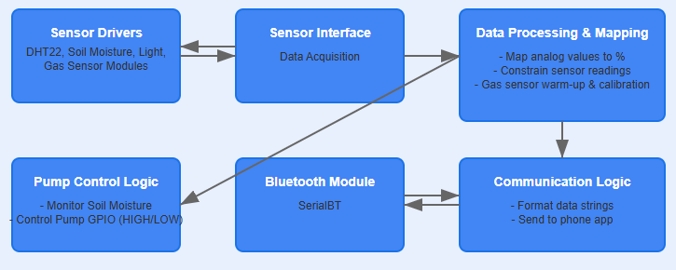
- The ESP32 reads sensor data every 2 seconds.
- After sensor readings, data is formatted and transmitted via BluetoothSerial to paired smartphone.
- Soil moisture data below threshold triggers a HIGH signal on the pump control pin.
- Arduino Uno listens to this signal and activates the water pump via relay.
- Gas sensor requires a 3-minute calibration on startup.
- Bluetooth communication uses Serial Port Profile (SPP).
Pseudocode:
Initialize Bluetooth, sensors, and pins

Loop every 2 seconds:

Read temperature and humidity from DHT22
Read soil moisture analog value and map to percentage
Read light intensity from photoresistor
Warm up gas sensor and read gas concentrations (CO, CH4, etc.)
Send all readings via Bluetooth to smartphone

If soil moisture < 50%:
Turn ON water pump relay
Else:
Turn OFF water pump relay

Integration:
- ESP32 and Arduino Uno communicate via a control pin to manage water pump.
- Bluetooth Serial enables wireless data transfer to a smartphone.
- Calibration and warm-up procedures are implemented for gas sensor stability.
- All sensors send analog data which can be read by the ADC pins of the ESP32.

Challenges and Solutions:
- Bluetooth pairing and connection stability: Re-initialized Bluetooth and ensured proper device naming.
- Gas sensor calibration delays: Implemented a warm-up timer and status messages.
- Analog sensor noise: Used mapping and constrained values to improve data accuracy.
- Power management: Separate power sources for the pump and microcontrollers to avoid voltage drops.

Usage steps:
- Power on the ESP32 and Arduino Uno.
- Pair your smartphone with the ESP32 Bluetooth device named "ESP32-Plant-Logger".
- Open a Bluetooth terminal app on the phone. and select device
- View real-time sensor readings streamed every 2 seconds or save it to your phone.
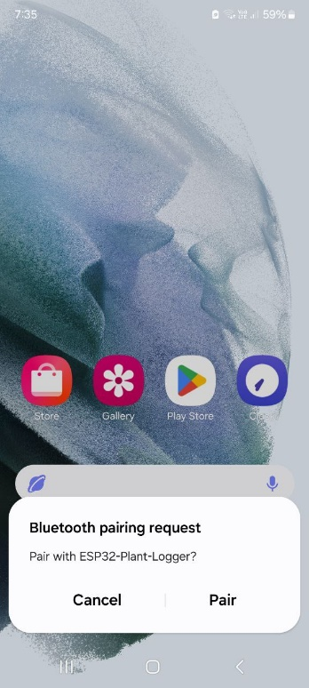
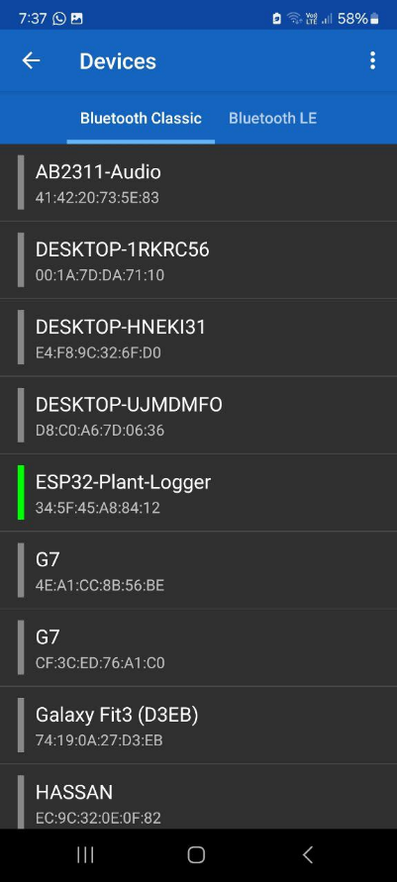
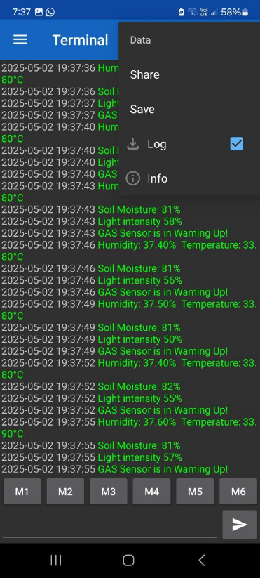

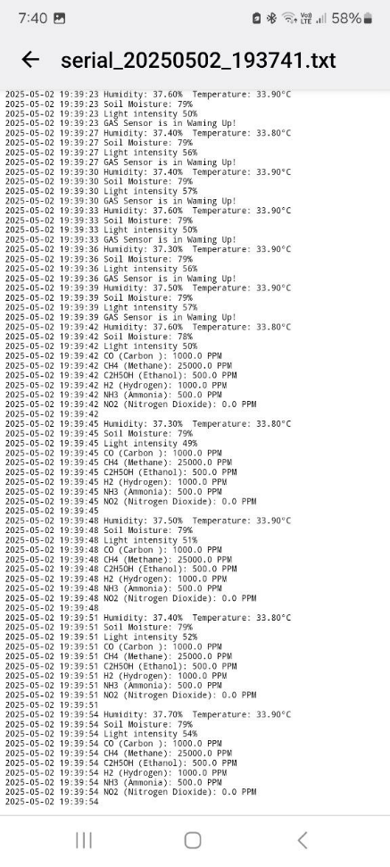
Step: 4
Step: 3
Step: 2
VI. Results and Discussion
- The system successfully monitored all targeted plant vitals.
- Soil moisture control effectively activated the water pump when below threshold.
- Bluetooth transmission was stable with accurate data reception on the smartphone.
- Gas sensor readings showed expected variations under different environmental conditions.
- Objectives for data acquisition, wireless transmission, and irrigation automation were met.
- Minor latency in sensor reading due to gas sensor warm-up was acceptable.

Overall, the project demonstrated a functional multi-sensor plant monitoring and irrigation system.
VII. Conclusion
This project successfully developed an ESP32-based plant vitals monitor integrating multiple sensors and wireless communication. Automated irrigation based on soil moisture was achieved via Arduino-controlled pump. The system provides valuable real-time data on environmental conditions affecting plant health. The experience highlighted the importance of sensor calibration, power management, and reliable communication protocols. Future work may focus on developing a dedicated mobile app and integrating cloud data storage for remote monitoring.

